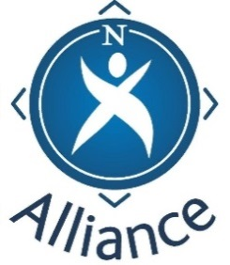
Celebrating Covid Learning
in the North 2020

Case-study title:

Local Authority area:

Organisation name:

What activities did your group do over lockdown that you wish to highlight?
(Maximum 200 words)

Who did it involve, including partners or other community organisations?
(Maximum 50 words)

What difference did it make?

How did this change your outlook, practice, work, and how might this have an impact long term? (Maximum 200 words)

What gaps have you identified through this work that needs to be looked at?

This information will be used to celebrate the fantastic work done during the pandemic by communities and community groups in the north. We intend to share it on-line with the Community Learning and Development (CLD) sector to help demonstrate and inform the key role CLD has to play in Scotland’s recovery from COVID. By providing this case study, you are consenting that this information can be shared.

Contact name:
Email address:
Date:

North Alliance – Who are we?
The North Alliance is a partnership of Community Learning and Development practitioners from the north of Scotland: Shetland, Orkney, Western Isles, Highland, Moray, Argyll and Bute, Aberdeen, and Aberdeenshire. We meet throughout the year with a key aim of furthering professional learning and practice in CLD.
2020 has seen an awe-inspiring list of initiatives developed in response to the Covid 19 virus. Vulnerable people of all ages have been supported with their personal needs. Staff and volunteers have developed skills to deliver digital on-line learning and a range of creative solutions has been found to meet the needs in our communities. New partnerships have been created and new ways of doing things have emerged with a focus on helping those most in need.
North Alliance want to celebrate all this, learn from it, acknowledge the difference it has made in our communities, and share it across the north to help demonstrate and inform the key role CLD has to play in Scotland’s recovery from COVID.

We would be very grateful if you could complete
and return this template to june.porter@shetland.gov.uk
by 25 February 2021

